Matthew Hoffman

CpE 403 – Advanced Embedded Systems

Lab 4

# Task 1:

Task 1 wanted us to determine the current period and on-time of the LED blinking. Change the delay of the LED blink (approx. 0.333 sec) by changing the clock source and configuration – do not change the delay value – determine the CLK frequency – verify the delay to be approx. 0.333 sec. This was accomplished by changing the SYSDIVIDER to 11. This takes the 400MHz clock which is inherently divided by 2 and then divided by 11 giving the proper clock frequency given that we cannot change the delay which is 6,000,000 CPU cycles. By dividing by 11 we get a clock that is approximately 18MHz.

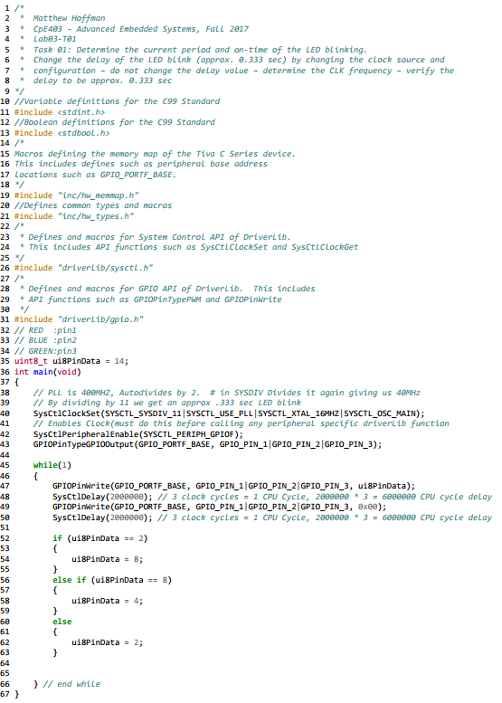

Figure 1. Lab03-T01 Source Code

# Task 2:

Task 2 wanted to change the sequence of the LED blinking and blink two LED at an instance and with a sequence.

## Task 2.A

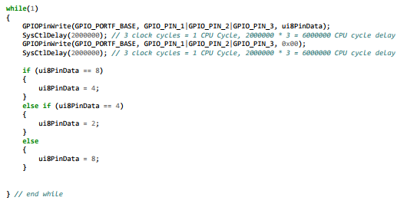

Figure 2. Lab03-T02.A Source Code Change for Sequence

## Task 2.B

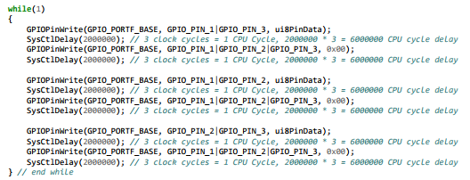

Figure 3. Lab03-T02.B Source Code Changes for Sequence and 2 LEDs blinking